Mexico Musical Dancing Dry Deck Water Fountain

Project Description:
This music dancing dry deck fountain project is located in Ixtapluca, Estado De Mexico for president celebration on July 1st, 2018, the design idea comes from the local hat, is novel and beautiful with the lively song, very suitable for local culture.This fountain mainly use jade column nozzles for running fountain and high technology one dimensional nozzles for dancing effect, mixed with the digital DMX 512 LED lights can catching the emotion of people.

Project Site：Ixtapluca, Estado De Mexico
Project Cost: RMB3, 000,000
Project Period: June,2018
Project Stage: Accomplished
Project Content: Design, Production, On-site Installation &Debugging

Project Reference Photos:
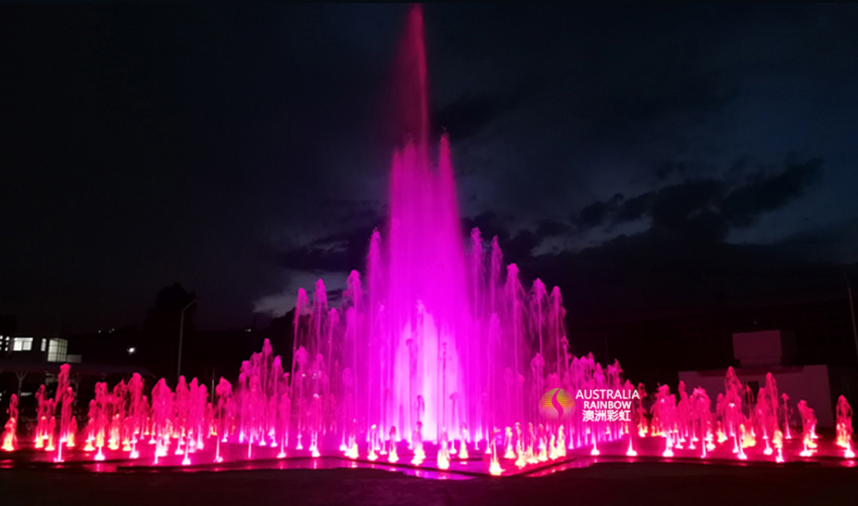
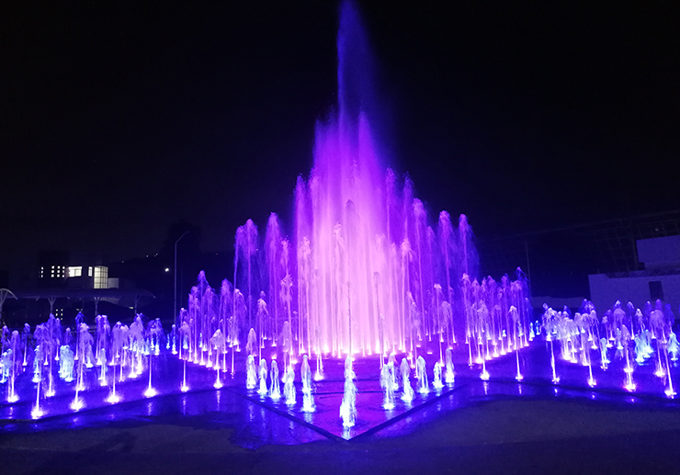

Design, contract, loading equipment, installation on site.
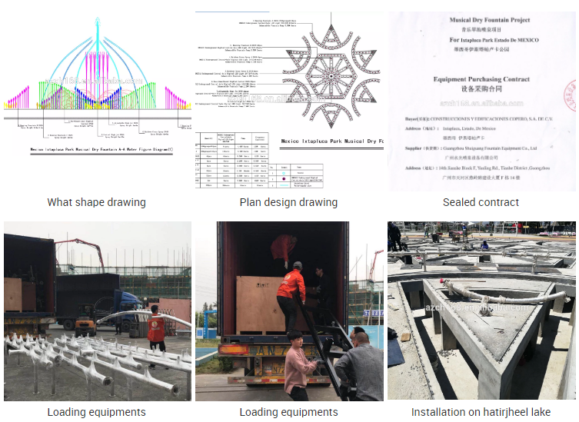

Programming on site
